- Create a new repository in GitHub and add a readme file
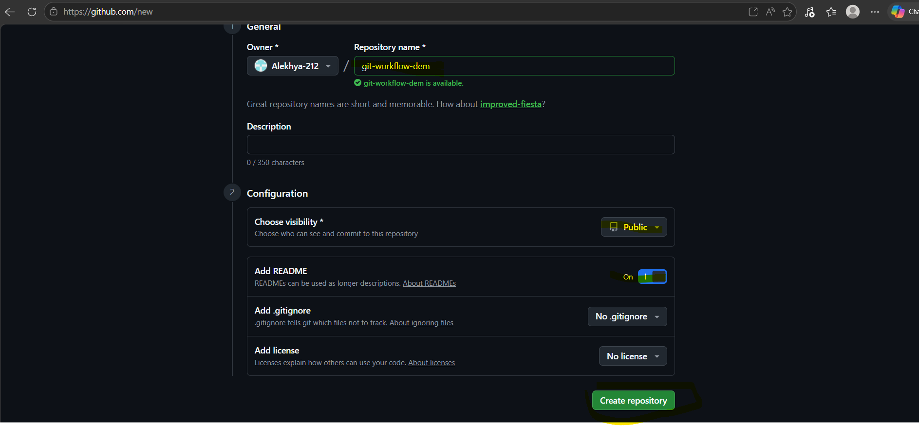
- Add the repo details in Git bash to access locally. Now we can access our repo remotely from our own machine.
Command: git remote add origin “URL of your repo”
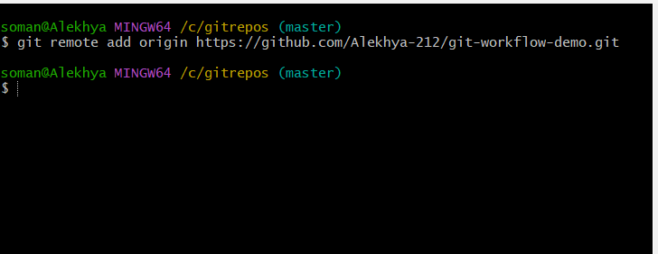

- Any application has branches for different developers to develop or add features to their code, so for my case I added 2 branches “dev” and “feature”
Command: git checkout -b branch name ( -b will let you create a branch newly instead of overwriting anything)
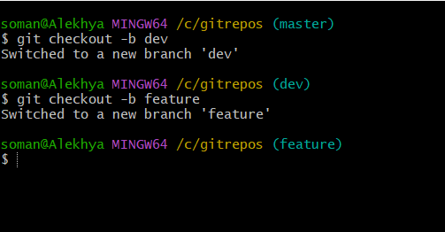
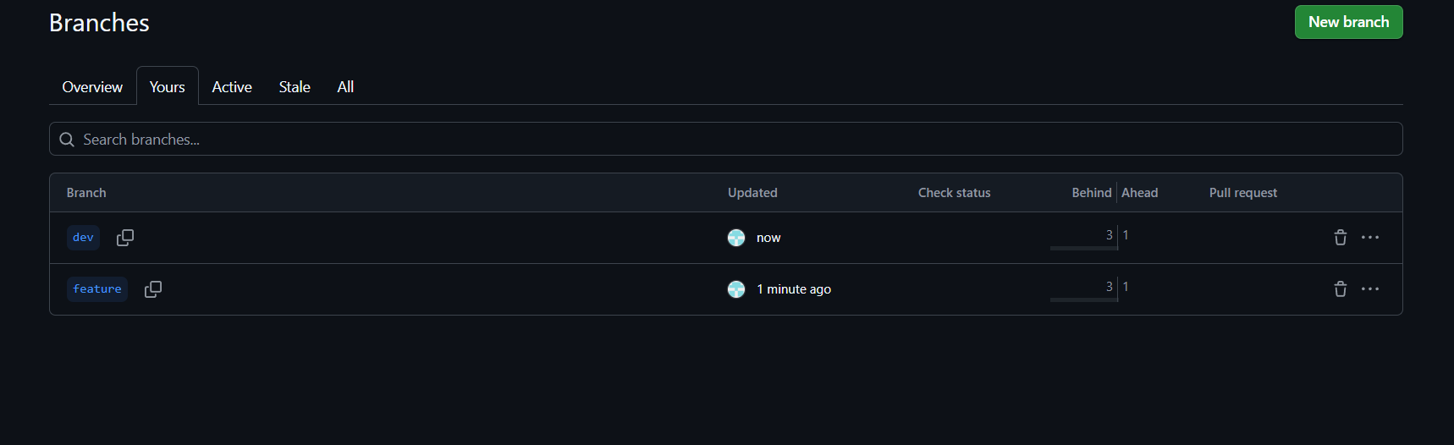
- I have a conflict error when I tried merging my feature and dev branches because both of them has a file name demo.txt
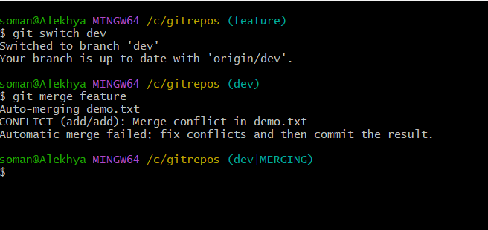

- I see two different statements, one from dev branch (which is in head) and the other from feature branch (below ==)
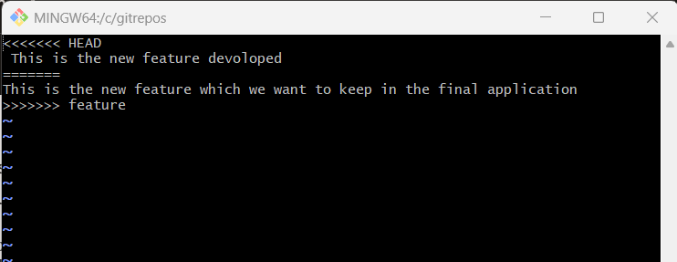
I want to keep them both, so I have edited it and kept them both
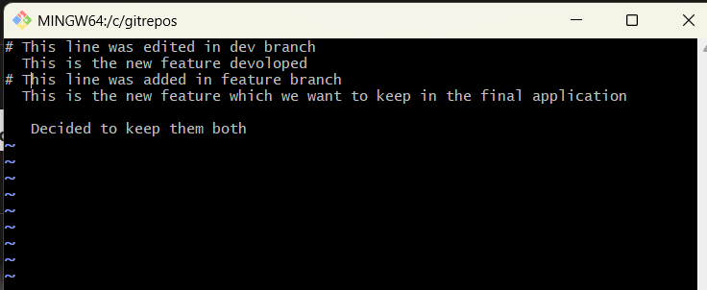

Now I don’t see any error
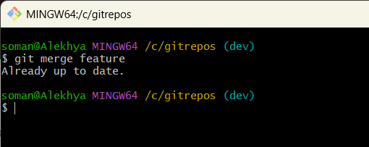

- This is before merging
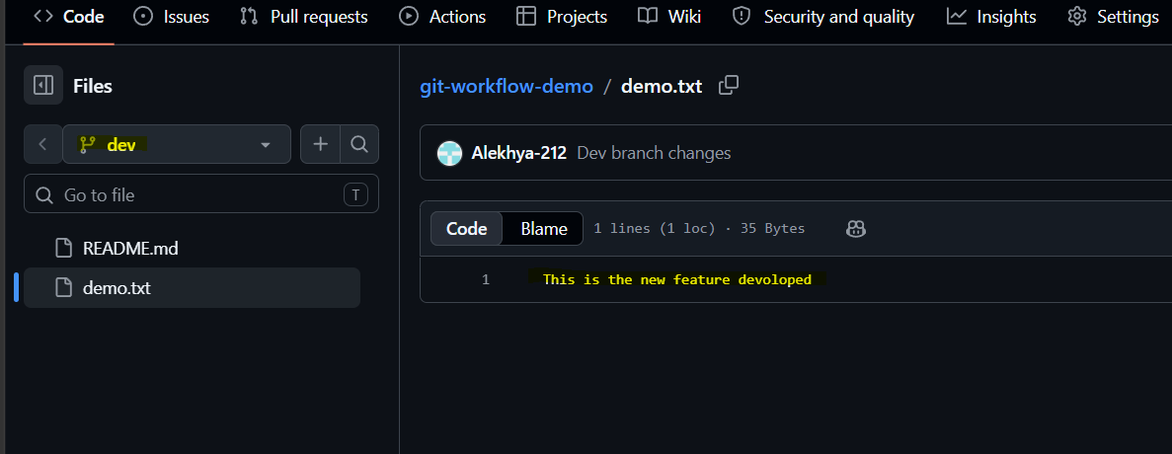
- This is after merging feature and dev branches
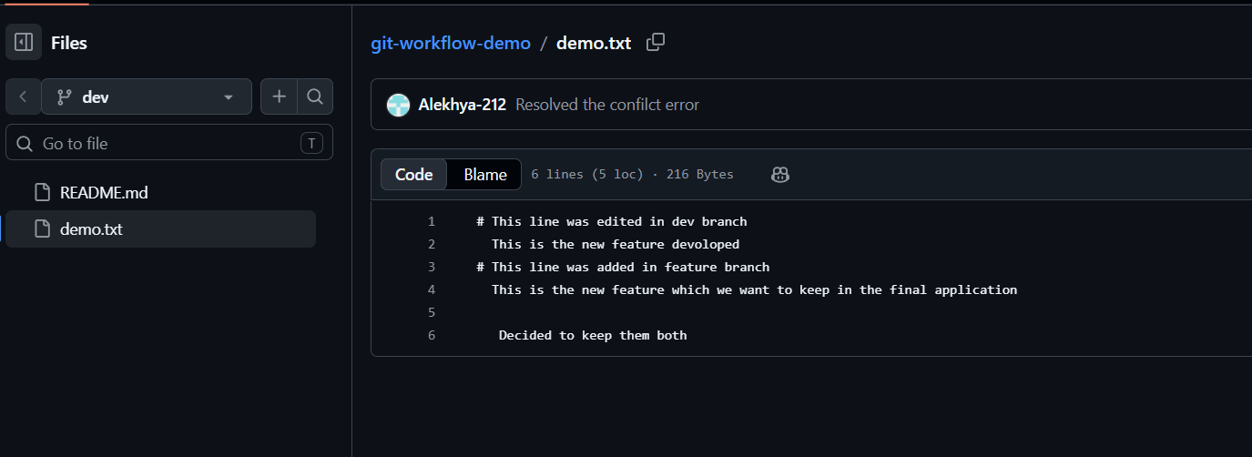

- I tried to rebase my feature with main but got a conflict because both main and feature have a same file name with different content
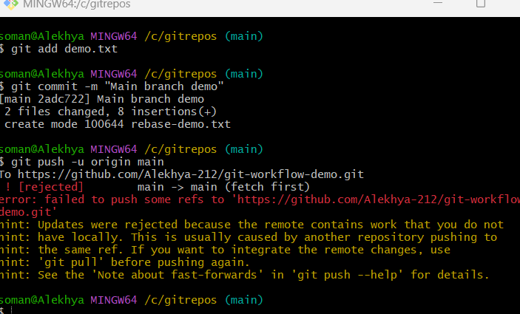

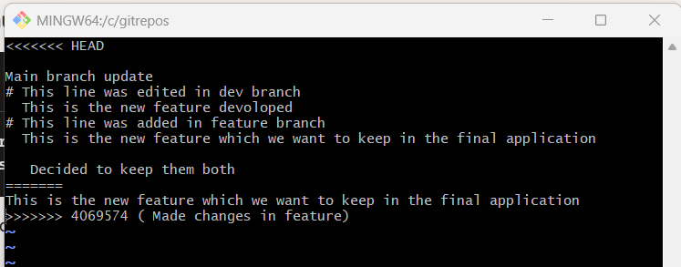

- Made changes and continued rebasing
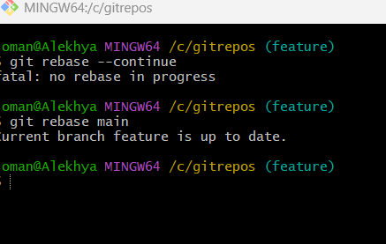
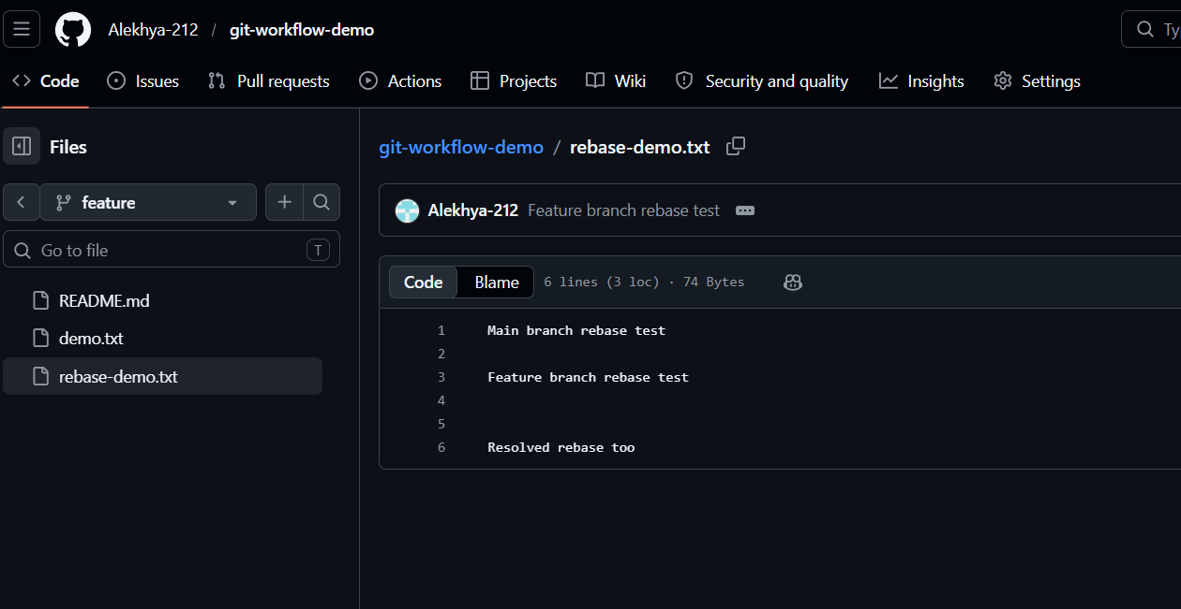

- Created a tag `v1.0` on the `main` branch to mark the first stable release.
Tags allow us to return to this exact version of the application at any time.
